## Lab Task

1 Attempt to reproduce as accurately as possible your own LAN – Local Area Network

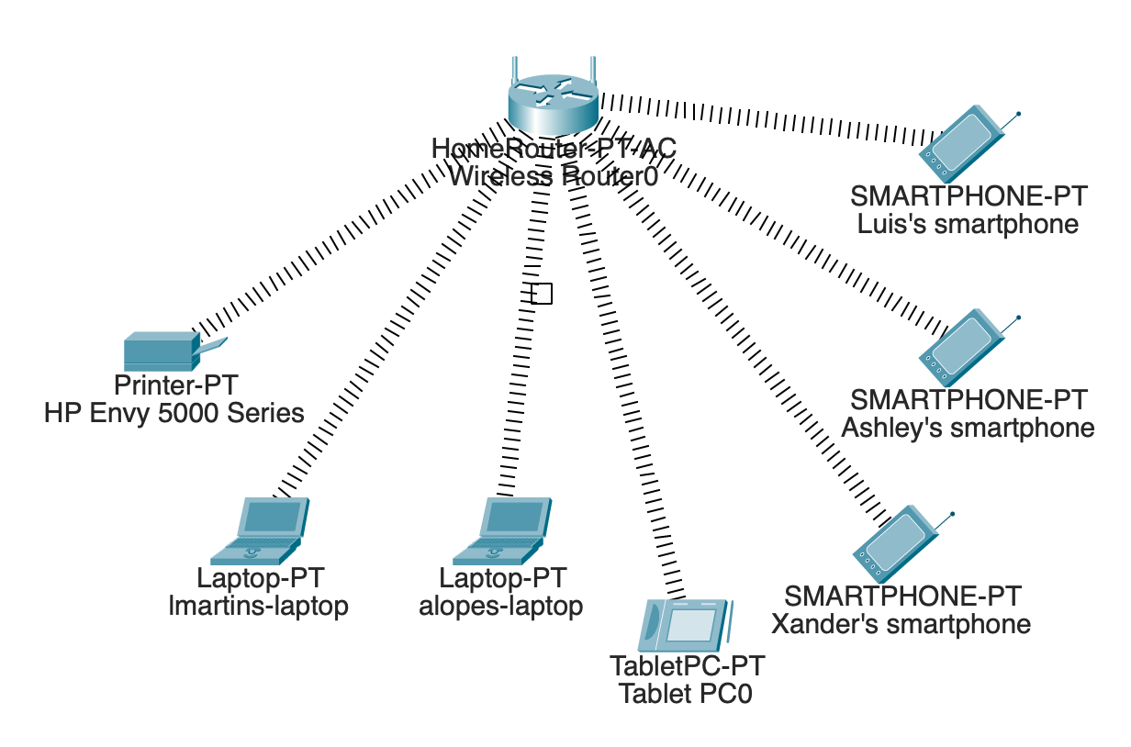

2 Attempt to resolve the configuration scenario below

“You can see from the scenario I have created above there is a typical wireless router setup which has connected to it : Tablet / Smart Phone / PC

But there is also a printer, 2 laptops and additionally 3 desktop machines.

But they are unable to connect. “

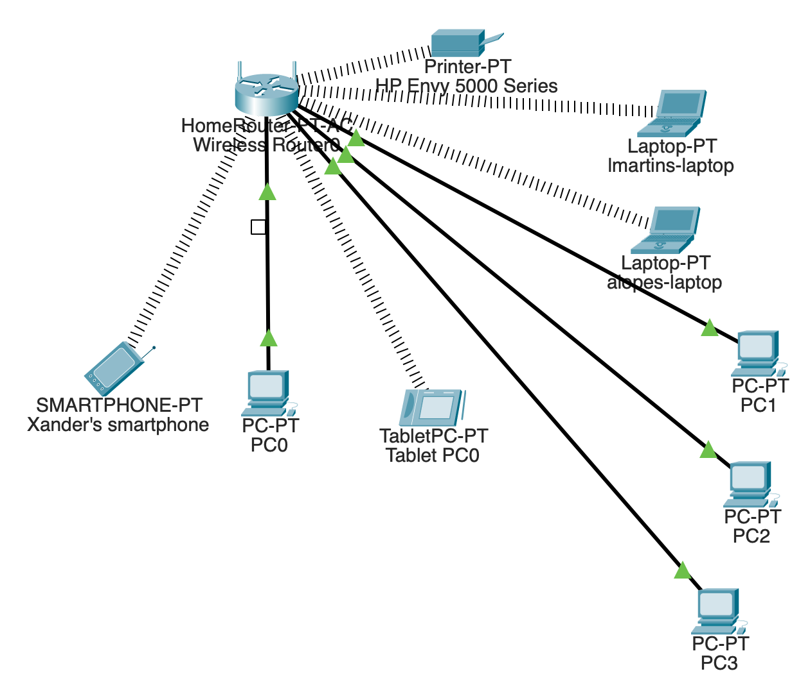

It was added a wireless module to the printer, and the PC’s are connected through ethernet cables.